# Epic Modul student

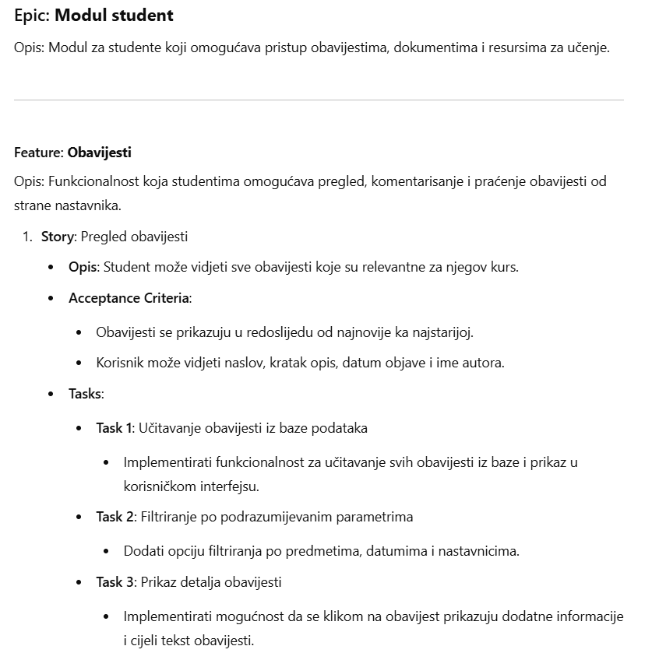

# Epic Modul nastavnik

